- The annualised inflation series shows substantial variation over the sample period. Inflation was relatively low and stable in the 1960s before rising sharply during the 1970s, reaching peaks of ~12% in 1974 and 1980 during the oil price shocks (Medley, 2013). Following the Volcker disinflation of the early 1980s, inflation declined and remained comparatively stable at around 2–3% through the 1990s and 2000s. A notable feature is the sharp deflation observed in 2008–2009 during the global financial crisis. The series does not appear stationary, as both the mean and volatility change substantially across different sub-periods
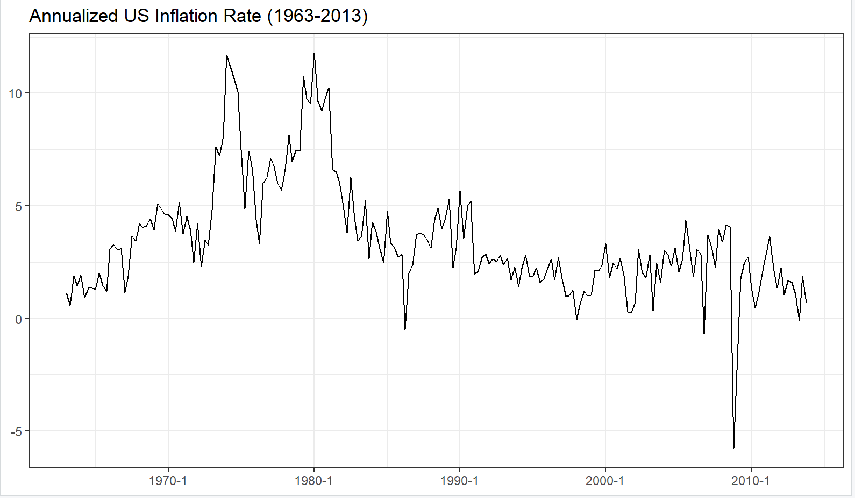
Figure 1: Annualized US Inflation Rate (1963Q1–2013Q4), computed as 400 × Δln(PCECTPI).
- The autocorrelation function displays high persistence in the inflation series. The lag-1 autocorrelation is approximately 0.83, indicating that inflation in one quarter is strongly correlated with the previous quarter. The autocorrelations decay slowly and remain statistically significant (exceeding the 95% confidence bounds) at all lags up to 20. This slow decay pattern is characteristic of a highly persistent or potentially non-stationary process, suggesting that shocks to inflation have long-lasting effects. The pattern is inconsistent with white noise, where autocorrelations would be approximately zero at all non-zero lags.
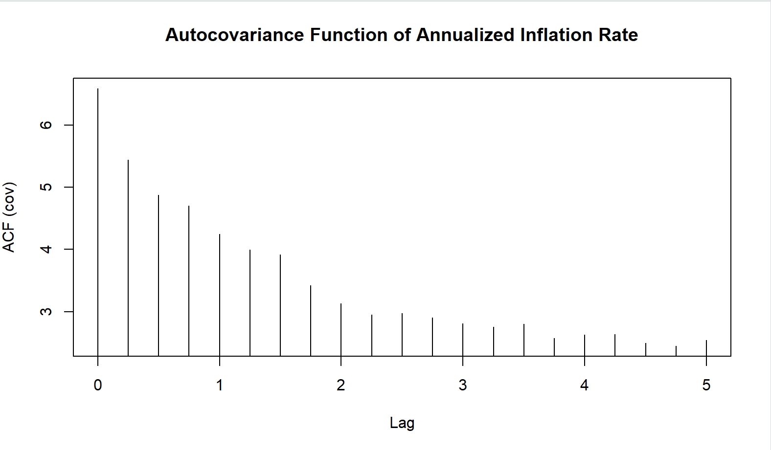
Figure 2: Autocovariance Function of the Annualized US Inflation Rate (1963Q1–2013Q4) up to 20 lags.

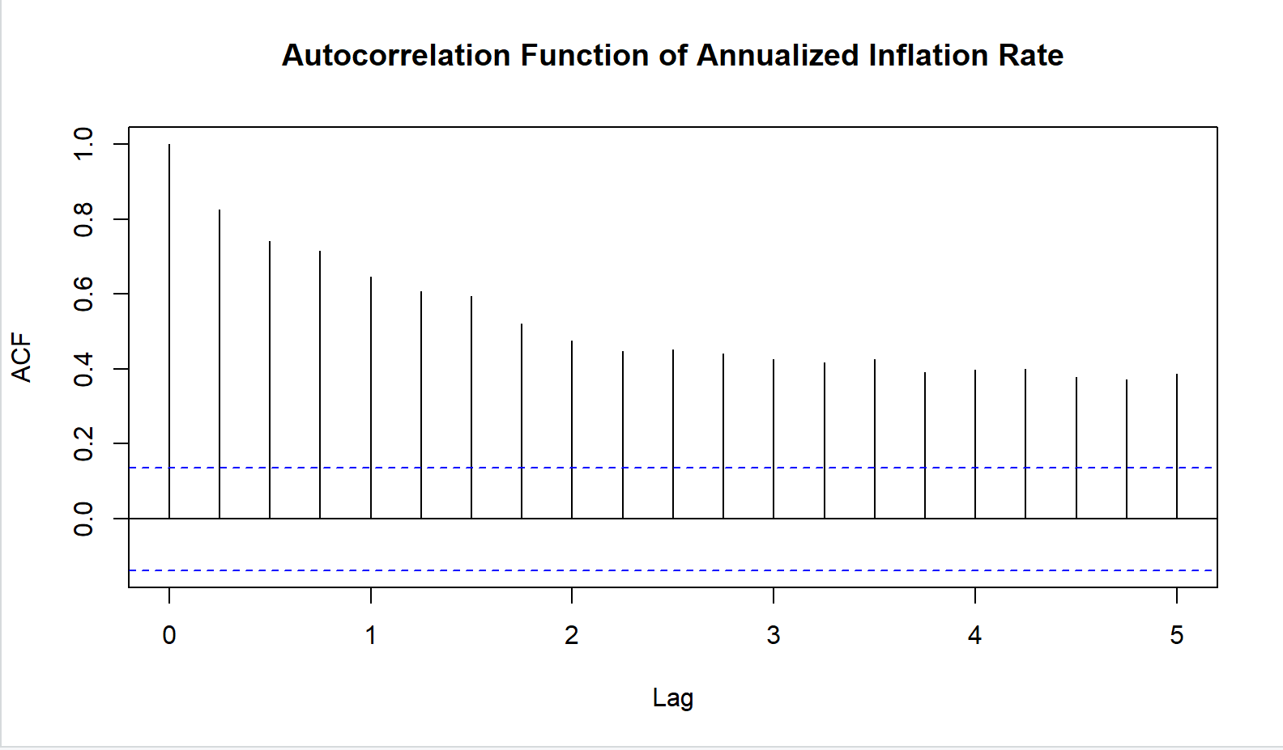
Figure 3: Autocorrelation Function (ACF) of the Annualized US Inflation Rate (1963Q1–2013Q4) up to 20 lags. Blue dashed lines indicate 95% confidence bounds.
- The ACF of the first differenced inflation series differs markedly from the ACF of the level series. Whereas the original inflation series exhibited high persistence with slowly decaying autocorrelations that remained significant at all 20 lags, the differenced series shows autocorrelations that are small in magnitude and mostly statistically insignificant. Only the first lag shows a modest negative autocorrelation of approximately -0.2. This pattern is consistent with a stationary process resembling white noise. The comparison suggests that while the inflation level is highly persistent and potentially non-stationary, the change in inflation is approximately stationary. This implies that differencing has successfully removed the persistence from the series."
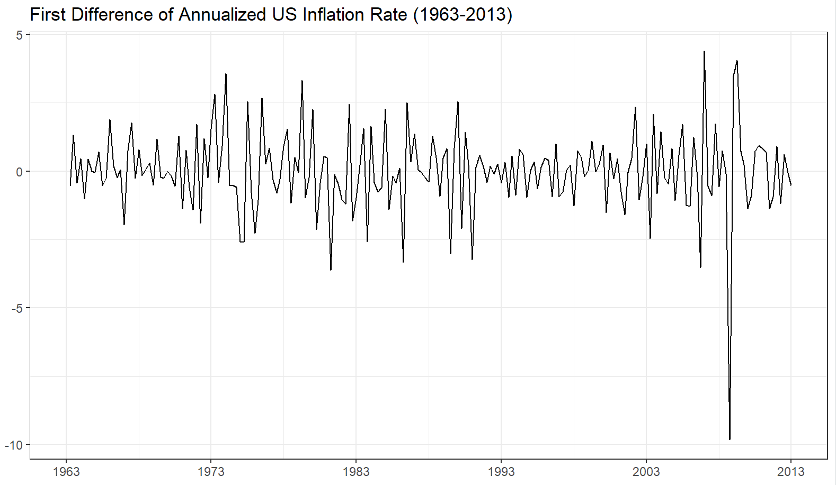
Figure 4: First Difference of the Annualized US Inflation Rate (1963Q1–2013Q4), computed as Δinfl_t = infl_t − infl_{t−1}.

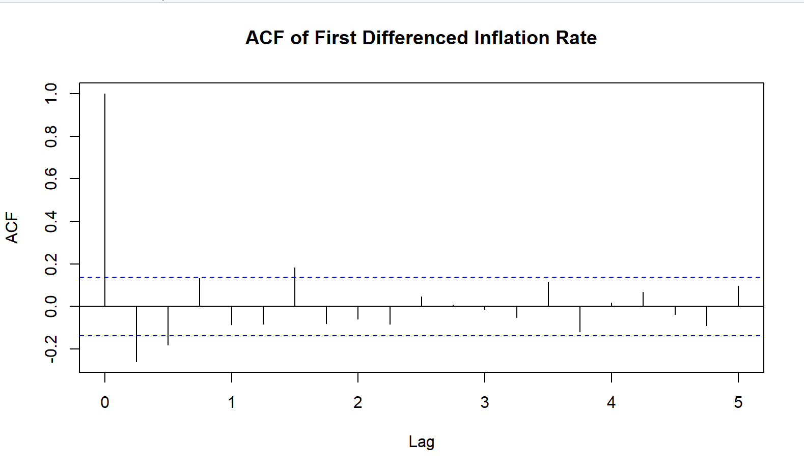
Figure 5: Autocorrelation Function of the First Differenced Inflation Rate up to 20 lags. Blue dashed lines indicate 95% confidence bounds.

